**PRACTICAL-10**

**AIM: Create a web application to demonstrate use of Grid view control and for inserting are cord from a database.**

**STEPS FOR CREATING AND VIEWING TABLE:**

1. Install and open Sql Server Management Studio
2. Set the server name as your desktop name \SqlExpress by default -> Click on connect

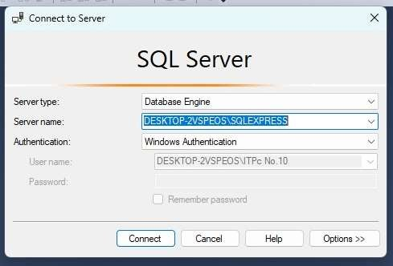

1. Now expand the Databases folder

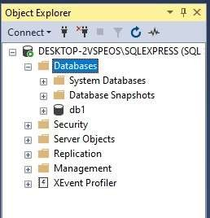

1. Click on new Database and give the database name -> Click on OK

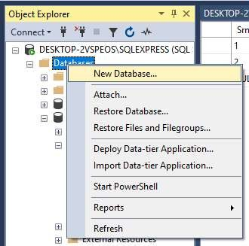

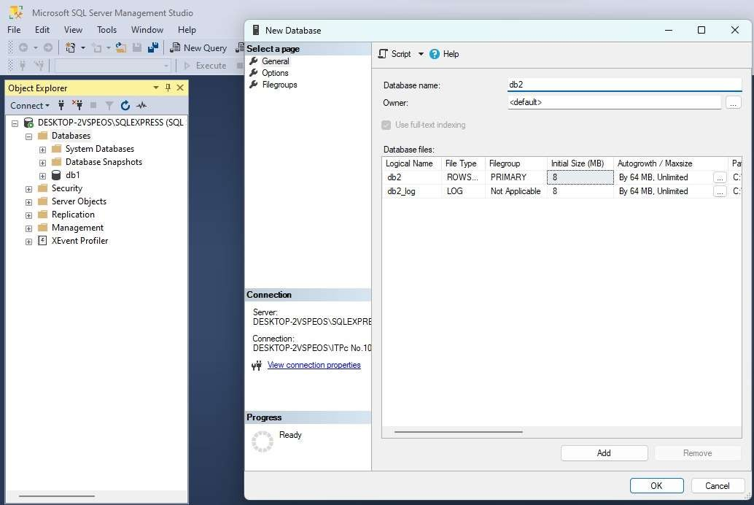

1. Expand your database ->Right click on the table folder->Click on new ->Click on table

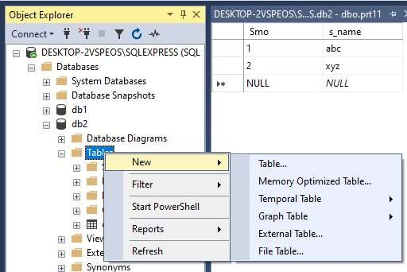

1. Give your table name and save

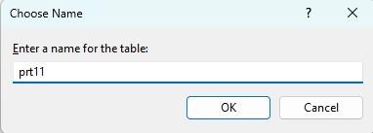

1. Refresh your table by clicking on Refresh option
2. Right click on your table -> Click on edit top 200 rows-> Add your records in the table.

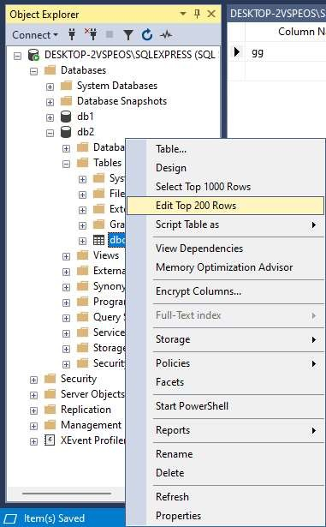

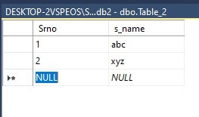

1. Now Drag GridView tool-> Click on SQL Data Source->Choose New Data Source->In Data Source Configuration Wizard tab-> Click on “SQL DATABASE”->OK-> New Connection

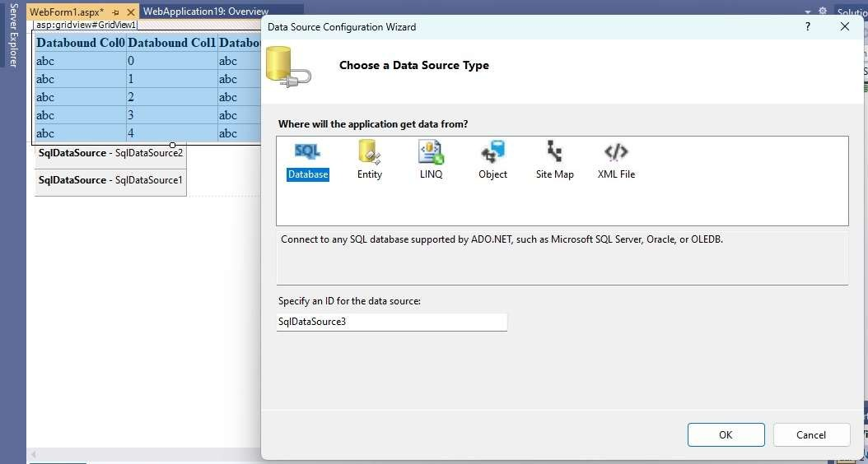

1. In Add Connection box-> “Data Source”-> Choose Microsoft SQL Sever(SqlClient)
2. Server Name: .\sqlexpress-> Select or enter your database -> Click on Test Connection->Click OK-> Then Next-> Copy the Connection String on notepad -> Next

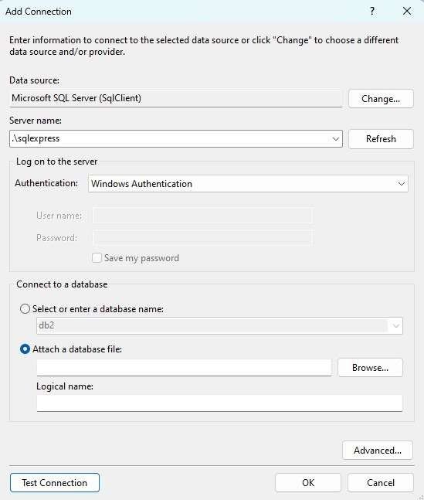

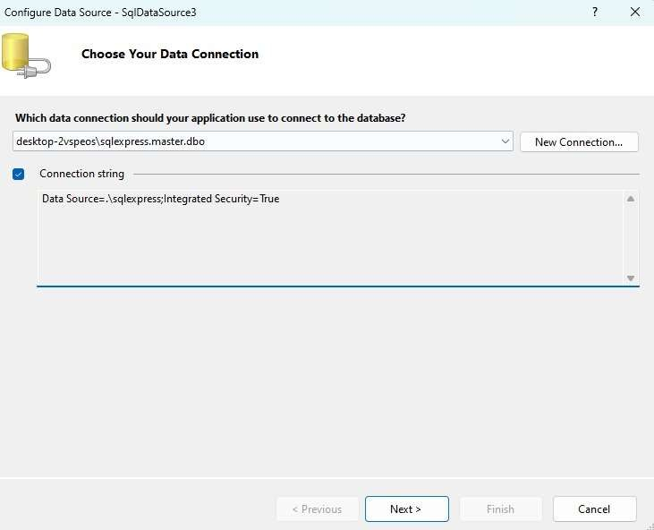

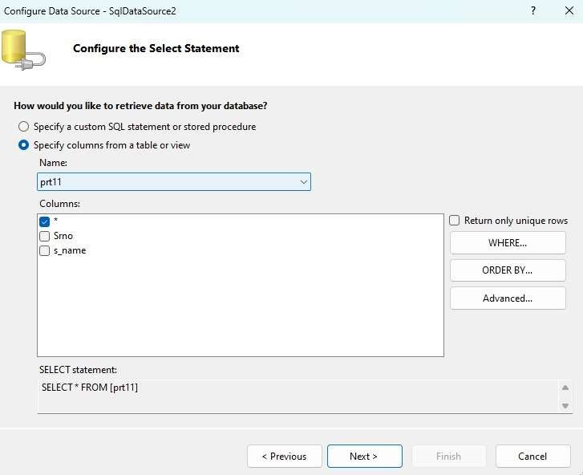

1. Select Table name -> Next-> Click on Test query (*Your table data must be displayed on testquery) -> Finish

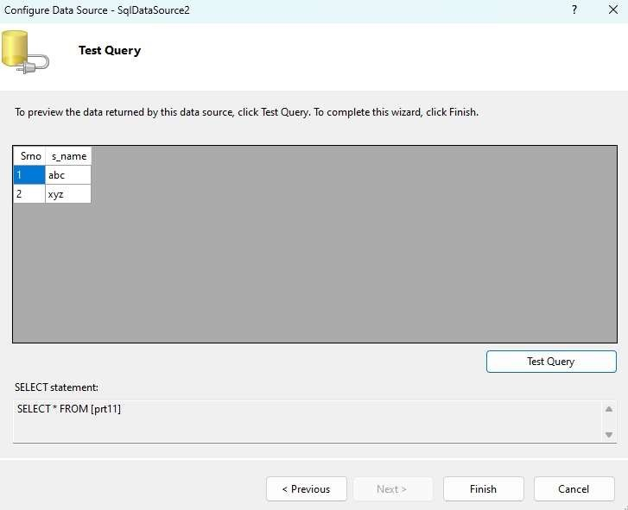

**\*Data Source=**.\sqlexpress;Initial Catalog=db2;Integrated Security=True

**WebForm1.aspx**

<%@ Page Language="C#" AutoEventWireup="true" CodeBehind="WebForm1.aspx.cs" Inherits="gridviewwww.WebForm1" %>

<!DOCTYPE html>

<html xmlns="<http://www.w3.org/1999/xhtml>">

<head runat="server">

<title></title>

</head>

<body>

<form id="form1" runat="server">

<div>

<asp:GridView ID="GridView1" runat="server" AutoGenerateColumns="False" DataKeyNames="SrNo" DataSourceID="SqlDataSource1" OnSelectedIndexChanged="GridView1_SelectedIndexChanged">

<Columns>

<asp:BoundField DataField="SrNo" HeaderText="SrNo" ReadOnly="True" SortExpression="SrNo"

/>

<asp:BoundField DataField="S_Name" HeaderText="S_Name" SortExpression="S_Name" />

</Columns>

</asp:GridView>

<asp:SqlDataSource ID="SqlDataSource1" runat="server" ConnectionString="<%$

ConnectionStrings:db1ConnectionString %>" SelectCommand="SELECT * FROM [pr10]"></asp:SqlDataSource>

<br />

</div>

</form>

</body>

</html>

**OUTPUT:**

